
BACHELOR THESIS
Faculty of Chemistry UAM
Program: Chemistry
Specialty:

The title of the work in Polish, in line with the APD theme (Calibri 14 pt. bold, regular, centred, single-spaced)
Title of the work in English (Calibri 14 pt. bold, regular, centered, single-line spacing)
Year of completion (Calibri, 14pt, bold, centred)
Student's full name, 12-point font, bold, regular, centered text
Album number, 12pt font, bold, regular, centered text
Experimental work carried out at the research facility named facility
Under the supervision of the title/degree, first name and surname of the Promotor, 12 pt, italics

Abstract: The content of the abstract should be written in Calibri font, regular, 11 points, with single line spacing, the text of the abstract should be aligned to both margins, written without paragraph breaks, with a maximum of 15 lines of text. The abstract text, including the keywords, cannot exceed one page.

Keywords: Calibri italic font; 11-point font size Five keywords; Separated by commas; Subsequent keywords in uppercase.
Introduction
The information in the introduction and other sections should be typed in Calibri font, size 11 points, with single line spacing. The text should be aligned with both margins. There should be a 6-point space after each paragraph. The work should be between 4-8 pages long.
Literary references cited as consecutive numbers in square brackets [1]. Literary references should be cited in accordance with the format adopted by ACS journals. Examples are given in the Literature section.
Tables and figures can be placed in a single-column or double-column layout, depending on their size. Examples are provided later in this template. Tables and figures should be numbered (Table 1, Figure 1, etc.). Table headings and figure captions should be typed in Calibri font, size 9pt. The content of the table should also be typed in Calibri font, size 9pt. In tables, only horizontal lines should be used to separate the table header row from the subsequent rows; columns should not be separated by lines.
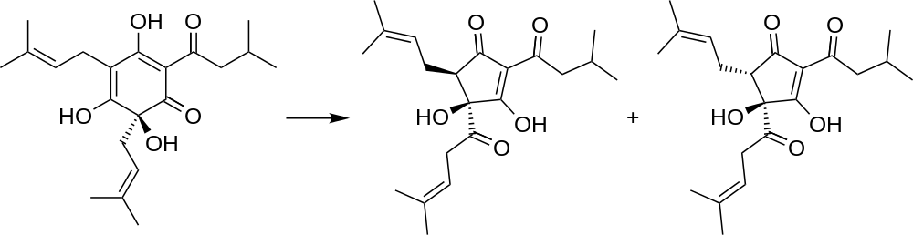
Figure 1.
Literary references cited as consecutive numbers in square brackets [1]. Literary references should be cited in accordance with the format adopted by ACS journals. Examples are given in the Literature section.
Tables and figures can be placed in a single-column or double-column layout, depending on their size. Examples are provided later in this template. Tables and figures should be numbered (Table 1, Figure 1, etc.). Table headings and figure captions should be typed in Calibri font, size 9pt. The content of the table should also be typed in Calibri font, size 9pt. In tables, only horizontal lines should be used to separate the table header row from the subsequent rows; columns should not be separated by lines.
Literary references cited as consecutive numbers in square brackets [1]. Literary references should be cited in accordance with the format adopted by ACS journals. Examples are given in the Literature section.
Tables and figures can be placed in a single-column or double-column layout, depending on their size. Examples are provided later in this template. Tables and figures should be numbered (Table 1, Figure 1, etc.).

Experimental part
Materials
The information in the introduction and other sections should be typed in Calibri font, size 11 points, with single line spacing. The text should be aligned with both margins. There should be a 6-point space after each paragraph.
Literary references cited as consecutive numbers in square brackets [1]. Literary references should be cited in accordance with the format adopted by ACS journals. Examples are given in the Literature section.
Equipment
The information in the introduction and other sections should be typed in Calibri font, size 11 points, with single line spacing. The text should be aligned with both margins. There should be a 6-point space after each paragraph.
Theoretical calculations
Literary references cited as consecutive numbers in square brackets [1]. Literary references should be cited in accordance with the format adopted by ACS journals. Examples are given in the Literature section.
Discussion of results
The information in the introduction and other sections should be typed in Calibri font, size 11 points, with single line spacing. The text should be aligned with both margins. There should be a 6-point space after each paragraph.
Part one of the work (if a division is necessary)
The information in the introduction and other sections should be typed in Calibri font, size 11 points, with single line spacing. The text should be aligned with both margins. There should be a 6-point space after each paragraph.
Literary references cited as consecutive numbers in square brackets [1]. Literary references should be cited in accordance with the format adopted by ACS journals. Examples are given in the Literature section.

Table 1.
No. | A | B | C | D | E | F
1.
2.
3.
4.

Literary references cited as consecutive numbers in square brackets [1]. Literary references should be cited in accordance with the format adopted by ACS journals. Examples are given in the Literature section.
Part two of the work (if a division is necessary)
Informacje zawarte we wstępie oraz pozostałych sekcjach należy wpisać czcionką Calibri rozmiar 11 pkt. z interlinią pojedynczą. Tekst należy wyrównać do obu marginesów. Odstęp po każdym paragrafie powinien wynosić 6 pkt.
Table 2.

Literary references cited as consecutive numbers in square brackets [1]. Literary references should be cited in accordance with the format adopted by ACS journals. Examples are given in the Literature section.
Literary references cited as consecutive numbers in square brackets [1]. Literary references should be cited in accordance with the format adopted by ACS journals. Examples are given in the Literature section.
Literary references cited as consecutive numbers in square brackets [1]. Literary references should be cited in accordance with the format adopted by ACS journals. Examples are given in the Literature section.
Summary
The information in the introduction and other sections should be typed in Calibri font, size 11 points, with single line spacing. The text should be aligned with both margins. There should be a 6-point space after each paragraph.
Literary references cited as consecutive numbers in square brackets [1]. Literary references should be cited in accordance with the format adopted by ACS journals. Examples are given in the Literature section.
Literary references cited as consecutive numbers in square brackets [1]. Literary references should be cited in accordance with the format adopted by ACS journals. Examples are given in the Literature section.
Literary references cited as consecutive numbers in square brackets [1]. Literary references should be cited in accordance with the format adopted by ACS journals. Examples are given in the Literature section.

Thank you
The information in the introduction and other sections should be typed in Calibri font, size 11 points, with single line spacing. The text should be aligned with both margins. There should be a 6-point space after each paragraph.
Literature
[1] Leopoldini, M.; Russo, N.; Toscano, M.; The molecular basis of the working mechanism of natural polyphenolic antioxidants, Food Chem., 2011, 125(2), 288-306
[2] Sattelberger, A. P. In Multiple Bonds between Metal Atoms; Cotton, F. A., Murillo, C. A., Walton, R. A., Eds.; Springer Science and Business Media: New York, 2005; Chapter 5.

