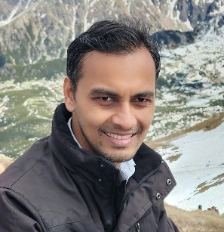
Ranjit Thakuria received his BSc (2000–2003) from B. Borooah College and MSc (2004–2005) from Gauhati University, India. He then moved to the University of Hyderabad, where he received his PhD (2011) in Crystal Engineering under the supervision of Professor Ashwini Nangia. After obtaining his PhD, he carried out one year postdoctorate with Professor William Jones at the University of Cambridge, UK (2011–2012). Then, he spent a year at Tel-Aviv University, Israel, as a postdoctoral researcher with (late) Professor Israel Goldberg (2013–2014). In 2014, he was appointed as an Assistant Professor (2014–2021) at the Department of Chemistry, Gauhati University, Assam. Currently, he is serving as an Associate Professor in the same department. His major research interest includes pharmaceutical cocrystals, heterogeneous catalysis, and design and synthesis of functional materials based on mechanochemistry. He is a recipient of multiple national and international awards including SERB-Young Scientist Award; Pioneering Investigators award by Chem. Commun., RSC for the year 2025; Emerging Investigators in Cryst. Growth Des., ACS for the year 2019 & 2022; and Teacher of the Year Awards 2021 by Academisthan foundation. He is also selected among the top 100 000 or 2% scientists for five consecutive years from 2021-2025 by Elsevier BV, Standford University. He served as a guest editor for a Cryst. Growth Des. virtual special issue on “π–π Stacking in Crystal Engineering: Fundamentals and Applications”. He has also been recognized as one of the Royal Society of Chemistry’s Outstanding Reviewer during the year 2021 & 2023. He has published more than 70 research articles in well reputed international journals including ACS Sustainable Chemistry & Engineering, Chem. Commun., ChemSusChem, Chem. Asian. J., J. Mater. Chem. C, Angew. Chem. etc. He is a reviewer of various international journals including CrystEngComm (RSC), Chem. Commun. (RSC), Cryst. Growth Des. (ACS), ChemSusChem (Wiley), International Journal of Pharmaceutics (Elsevier), etc. Currently he is working as an Ulam Nawa Fellow at the University of Warsaw, Poland.

